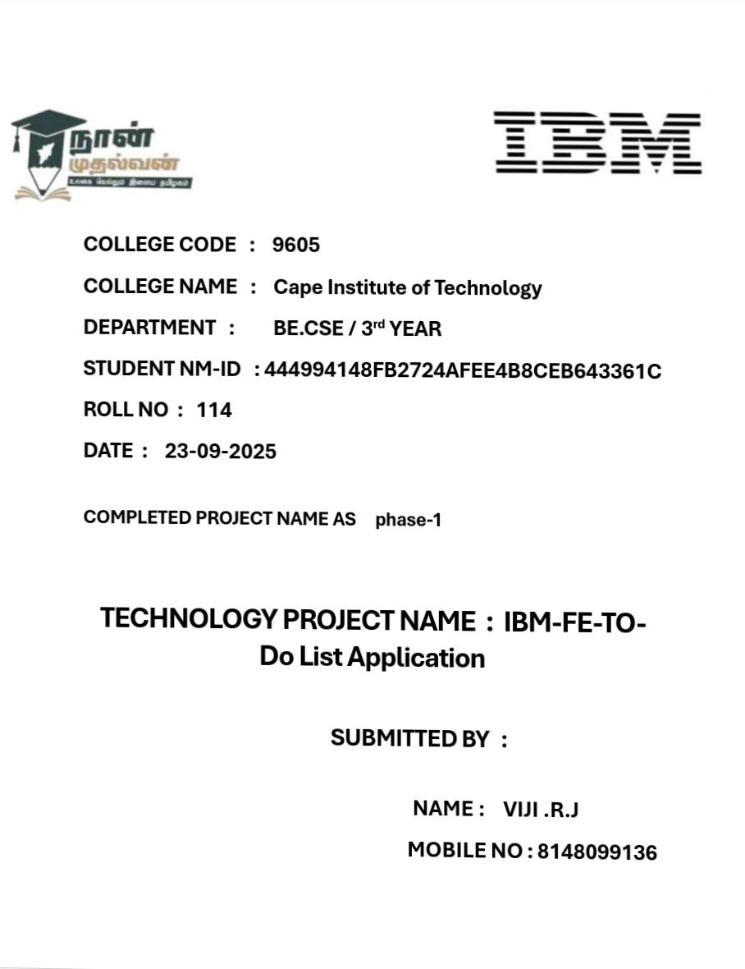

FE

–

TO DO LIST APPLICATION

Phase 5: Project Demonstration and Documentation

1. Introduction

A To-Do List Application is a simple yet powerful productivity tool that helps users manage daily activities effectively.

This project demonstrates how front-end web technologies can be used to create an interactive and user-friendly task management system.

The application provides essential features such as adding, editing, deleting, and tracking tasks, ensuring users stay organized and productive.

1. Project Overview

The FE–To-Do List Application is designed using front-end technologies like HTML, CSS, and JavaScript (or React).

It provides users a platform to organize their tasks efficiently, helping them prioritize and complete their work on time.

The project focuses on implementing CRUD operations (Create, Read, Update, Delete) and ensuring data persistence using LocalStorage.

1. Objectives
   * To develop a front-end web application for task management.
   * To implement CRUD functionalities.
   * To maintain data persistence across sessions.
   * To design a responsive and intuitive user interface.
   * To demonstrate integration with storage or API (optional).

1. Problem Statement

Managing daily tasks without a proper system can lead to disorganization and missed deadlines. The lack of digital tools for personal productivity inspired the development of a To-Do List web app that can be used anytime and anywhere.

1. Scope of the Project
   * This application is focused on front-end implementation.
   * It can later be extended with back-end APIs for user authentication and cloud storage.
   * Suitable for personal task management or as a base for team productivity apps.

1. Features of the Application
   1. Add, edit, and delete tasks.
   2. Mark tasks as completed.
   3. Filter tasks (All, Completed, Pending).
   4. Data stored in LocalStorage.
   5. Responsive web design.
   6. User-friendly interface with validation.
   7. Option to clear all completed tasks.
   8. Persistent data even after page refresh.

1. System Requirements

Hardware:

* + Processor: Intel i3 or higher
  + RAM: 4 GB minimum
  + Hard Disk: 250 MB free space

Software:

* + OS: Windows / macOS / Linux
  + Tools: VS Code, Browser (Chrome/Edge), Git
  + Deployment: Netlify / GitHub Pages

1. Technology Stack

Layer Technology

Front-End HTML, CSS, JavaScript / React

Database LocalStorage / JSON server

Tools VS Code, GitHub, Browser Developer Tools

Hosting GitHub Pages, Netlify, Vercel

1. System Architecture

Architecture Layers:

* 1. Presentation Layer: UI components for interaction.
  2. Logic Layer: Handles task creation, editing, deletion.
  3. Storage Layer: Manages data persistence using LocalStorage.

*(Include a diagram showing these three layers connected.)*

1. System Design
   * Home Page Layout: Task input, Add button, Task list area.
   * Interaction Flow: User input → JS Function → Data Stored → UI Updated.

Include:

* + UI Wireframe
  + Navigation Flowchart

1. Data Flow Diagram (DFD)

Level 0: User interacts with app → App processes → Tasks displayed.

Level 1: Input tasks → Validate → Store → Display → Update/Delete.

1. UML Diagrams
   * Use Case Diagram: Add, Edit, Delete, View Tasks.
   * Activity Diagram: User actions flow.
   * Sequence Diagram: Interaction between user and system functions.

1. Project Implementation

The implementation follows a modular approach:

* + UI development (HTML/CSS)
  + Logic implementation (JavaScript functions)
  + Data persistence (LocalStorage)

1. Modules Description

Module Description

Task Creation Adds a new task

Task Editing Modifies existing task

Task Deletion Removes completed task

Task Completion Marks as done

Data Storage Saves tasks persistently

1. Front-End Design

Includes:

* + HTML structure for task list.
  + CSS for layout, colors, and responsiveness.
  + JS event listeners for buttons and form submission.

1. Functionalities Implementation (Code Explanation)

Example Snippet:

function addTask() {

let taskInput = document.getElementById("task").value; if (taskInput === "") return alert("Please enter a task"); let tasks = JSON.parse(localStorage.getItem("tasks")) || []; tasks.push({ name: taskInput, completed: false }); localStorage.setItem("tasks", JSON.stringify(tasks)); displayTasks();

}

1. Project Demonstration (Walkthrough)
   1. Launch app
   2. Add new task
   3. Edit or delete task
   4. Refresh → Data remains
   5. View completed and pending tasks

1. Screenshots

Include:

* + Homepage
  + Adding task
  + Editing
  + Completed tasks
  + Mobile view

1. API Documentation (if applicable)

Endpoint Method Description

/tasks GET Retrieve tasks

/tasks POST Add new task

/tasks/:id PUT Update

/tasks/:id DELETE Delete

1. Data Storage Explanation

All tasks are stored in LocalStorage in JSON format. This ensures persistence even after page reload.

1. Testing and Validation
   * Unit Testing: Validated functions for add/edit/delete.
   * UI Testing: Verified button clicks and visual feedback.
   * Responsiveness: Tested on mobile and desktop.

1. Deployment Process

Steps:

* 1. Push code to GitHub.
  2. Link to Netlify or GitHub Pages.
  3. Deploy main branch.
  4. Test deployed link.

1. Challenges Faced & Solutions

Challenge Solution

Data lost on reload Used LocalStorage

Edit not updating properly Implemented array indexing

Layout breaking on mobile Used Flexbox and Media Queries

24.Security and Optimization

* + Input validation to prevent empty tasks.

* + Code modularization for performance.

* + Efficient DOM updates for smooth rendering.

25.Performance Evaluation

Fast load time.

Low memory usage.

Efficient LocalStorage operations.

26.Future Enhancements

* 1. Add login and user profiles.

* 1. Cloud storage (Firebase).

* 1. Notifications for pending tasks.

* 1. Dark/Light mode.

27.GitHub README & Setup Guide

Include:

Clone steps

Setup commands

Run instructions

Screenshots

28.Conclusion

The FE-To-Do List Application successfully demonstrates front-end development concepts, CRUD operations, and data management. It provides a foundation for further development into a full-stack productivity app.

29.References

* Mozilla Developer Network (MDN)

* W3Schools

* Stack Overflow

* GitHub Docs

Challenges and Solutions

During the development of the Front-End To-Do List Application, several technical and design-related challenges were encountered.

This section highlights the major problems faced during each phase of the project and the corresponding solutions implemented to overcome them.

1. Challenge: Managing State and Task Updates

Description:

While developing the core functionality, managing the state of multiple tasks became complex. When tasks were edited or marked as completed, changes did not always reflect correctly in the UI.

Reason:

The state (list of tasks) was not being updated consistently after each operation, especially during edit or delete actions.

Solution:

A centralized task array was introduced, and every operation (add, edit, delete, complete) was made to update both:

The in-memory array

The browser’s LocalStorage

Example Implementation:

Function updateTask(index, newTask) { Tasks[index].name = newTask; localStorage.setItem(“tasks”, JSON.stringify(tasks)); displayTasks();

}

This ensured the UI and storage remained synchronized after every user action.

# 2. Challenge: Data Loss After Page Refresh

Description:

Initially, all tasks disappeared once the page was reloaded.

Reason:

The data was being stored only in temporary JavaScript variables, not persistently.

Solution:

To solve this, LocalStorage was implemented to store the data permanently in the browser.

Tasks are saved as a JSON string, and retrieved every time the page loads.

Code Example:

Let tasks = JSON.parse(localStorage.getItem(“tasks”)) || [];

This ensures that even after closing or refreshing the browser, tasks remain intact.

3. Challenge: Responsive Design for Multiple Devices

Description:

The application layout was breaking when viewed on smaller screens such as mobiles or tablets.

Reason:

The design used fixed widths and absolute positioning without media queries.

Solution:

Used Flexbox and CSS media queries to make the design responsive.

Now, the interface automatically adjusts its layout based on the screen size.

Example:

@media screen and (max-width: 600px) {

.task-container {

Flex-direction: column;

}

}

# 4. Challenge: Handling Duplicate Task Entries

Description:

Users could accidentally add the same task multiple times, which cluttered the list.

Reason:

No validation check was implemented before adding a new task.

Solution:

A validation function was added to check whether a task with the same name already exists before inserting it.

Code Example:

If (tasks.some(t => t.name.toLowerCase() === taskInput.toLowerCase())) {

Alert(“Task already exists!”);

Return;

}

5. Challenge: Deleting or Editing Specific Tasks

Description:

When multiple tasks existed, clicking “Edit” or “Delete” sometimes affected the wrong task.

Reason:

Each task item didn’t have a unique identifier.

Solution:

Added a unique ID (timestamp or index-based) for every task.

Operations were then performed based on this ID instead of task name or position.

Tasks.push({ id: Date.now(), name: taskInput, completed: false });

# 6. Challenge: Maintaining Code Readability

Description:

As new features were added, the JavaScript file became lengthy and hard to manage.

Reason:

All functions were written in one script block without modularization.

Solution:

Divided the code into smaller, reusable functions for:

Adding tasks

Editing tasks

Deleting tasks

Rendering the task list

This improved maintainability and debugging.

7. Challenge: Providing Visual Feedback to Users

Description:

Users were unsure whether their action (add/edit/delete) was successful because the UI didn’t give immediate feedback.

Solution:

Added alert messages, icons, and animations.

For example, completed tasks now appear with a strikethrough and a check icon, enhancing clarity.

.completed {

Text-decoration: line-through;

Color: gray;

}

1. Challenge: Version Control and Collaboration Description:

Keeping track of multiple versions during development caused confusion.

Solution:

Used GitHub for version control:

Created commits after each feature implementation.

Used separate branches for new features and merged after testing.

1. Challenge: Deployment Issues

Description:

During deployment on Netlify, paths to CSS and JS files were not loading correctly.

Reason:

Incorrect relative file paths in the HTML file.

Solution:

Used relative pathing (./css/style.css instead of /css/style.css) and verified all resources were in the correct directory structure.

After correction, deployment was successful.

Challenge: Maintaining Performance and Speed

Description:

As the task list grew, performance slowed slightly when updating or rendering tasks.

Solution:

Used optimized rendering by clearing and re-rendering only updated parts of the DOM, and minimized frequent LocalStorage writes.

This improved performance and responsiveness.

Summary Table

Challenge Cause Solution Implemented

State not updating No centralized task handling Used task array & LocalStorage

Data loss after refresh No persistent storage Implemented LocalStorage

Layout breaking on mobile Fixed-width design Added responsive CSS

Duplicate tasks No validation Added duplicate check

Wrong task edited/deleted No unique ID Added task IDs

Code hard to manage Single large script Modularized functions

No user feedback Missing alerts & styles Added visual indicators

Version confusion No version control Used Git & GitHub

Deployment errors Incorrect paths Fixed relative paths

Performance drop DOM re-rendering inefficiency

Optimized updates

Screenshot:

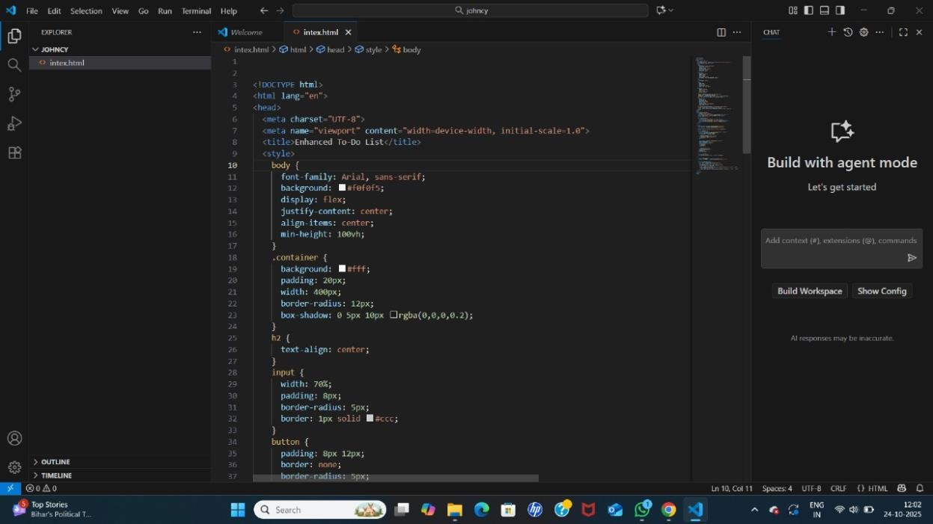

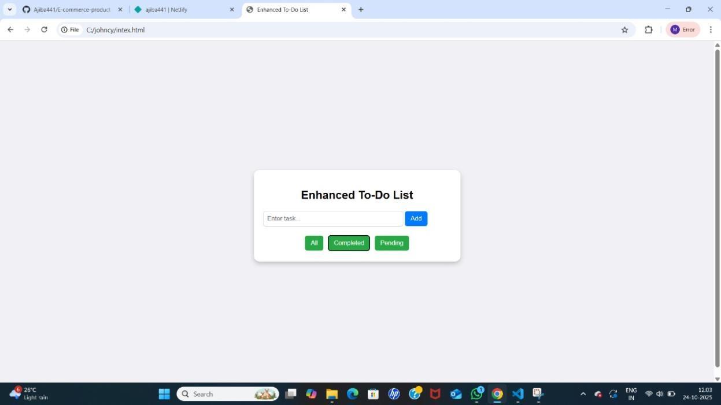

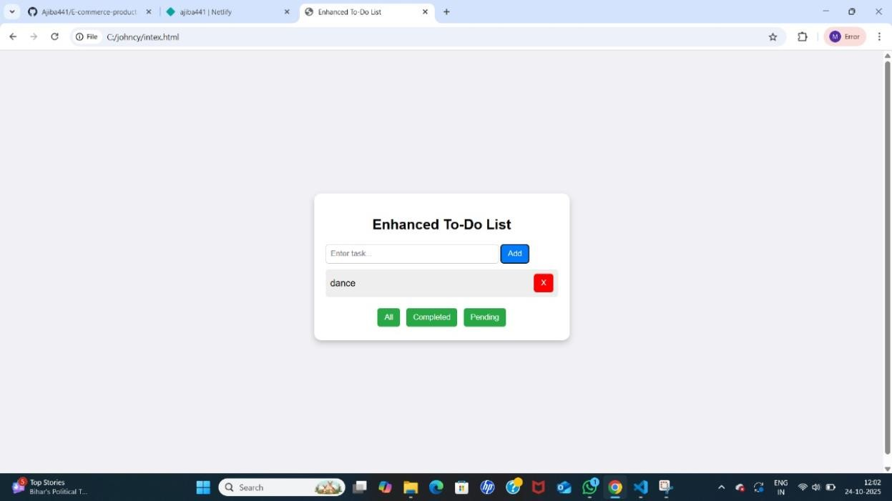

GitHub Repository:

<https://github.com/vijirj0938-code/Viji.git>